**MIDTERM TEST**

**(1 tiếng rưỡi)**

# Task 1: Review general knowledge. Please find the correct answer to each question. (3p)

## **Which of the following operators is used to compare with pattern matching data from the database?**

1. LIKE
2. SELECT
3. IN

*Your answer: A*

## **What is SQL execution order?**

## SELECT [TOP] 🡪 FROM 🡪 WHERE 🡪 JOIN 🡪 UNION 🡪 ORDER BY

## FROM 🡪 WHERE 🡪 JOIN 🡪 SELECT 🡪 GROUP BY 🡪 ORDER BY 🡪 LIMIT (TOP N)

## FROM 🡪 JOIN 🡪 WHERE 🡪 GROUP BY 🡪 SELECT 🡪 ORDER BY 🡪 LIMIT (TOP N)

*Your answer: C*

## **Which method can help you to query data from multiple tables?**

1. Subquery
2. JOIN
3. UNION
4. All the above answers

*Your answer: D*

## **Which JOIN query results in the below output table?**

## INNER JOIN

## LEFT JOIN

## RIGHT JOIN

## FULL JOIN

*Your answer:B*

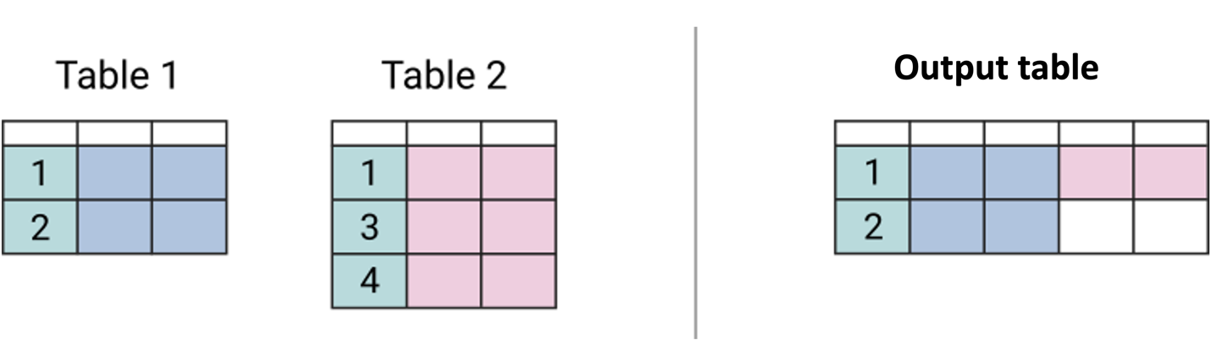

## **1.5. Which JOIN query results in the below output table?**

## INNER JOIN

## LEFT JOIN

## RIGHT JOIN

## FULL JOIN

*Your answer: D*

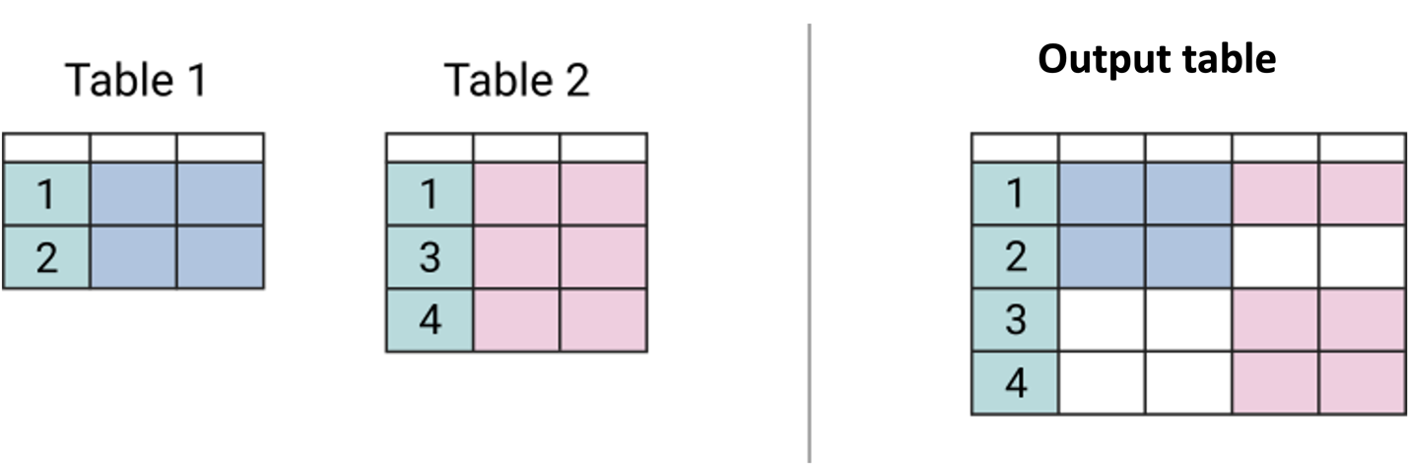

# Task 2: Write queries based on following requirements (3p)

## Retrieve a report that includes the following information*a*. These transactions must meet the following conditions: (1.5p)

# Were created in Feb 2019

# Transaction type is not empty (transaction type IS NOT NULL)

*-- Your code here:*

-- 2.1

SELECT customer_id

    , transaction_id

    , sce.scenario_id

    , transaction_type

    , sub_category

    , category

FROM fact_transaction_2019 as fact_19

LEFT JOIN dim_scenario AS sce

    ON sce.scenario_id = fact_19.scenario_id

WHERE MONTH(fact_19.transaction_time) = 2

        AND transaction_type IS NOT NULL

## From payment transaction history in February 2019. **Find the top 10% of failed transactions with the highest transaction value *(charged_amount)***. (1.5p)

*( yêu cầu là tìm ra top 10% giao dịch thất bại của nhóm “Payment” (không thành công) có giá trị charged_amount cao nhất trong tổng số giao dịch payment trong tháng 2/2019)*

*-- Your code here:*

SELECT TOP 10 PERCENT customer_id

    , transaction_id

    , charged_amount

FROM fact_transaction_2019 as fact_19

LEFT JOIN dim_scenario AS sce

    ON sce.scenario_id = fact_19.scenario_id

LEFT JOIN dim_status as stt

    ON stt.status_id = fact_19.status_id

WHERE MONTH(fact_19.transaction_time) = 2

    AND transaction_type = 'Payment'

    AND status_description = 'Payment failed'

ORDER BY charged_amount DESC

# Task 3: Retrieve an overview report of customer’s payment behaviors

## Paytm has acquired a lot of customers. Retrieve a report that includes the following information: ***the number of transactions, the number of payment scenarios, the number of payment category and the total of charged amount of each customer***. Some additional conditions need to be met: (2p)

* Only show Top 10 highest customers by the total of charged amount
* Transactions created from 01/01/2020 to 31/03/2020
* Status description is successful
* Transaction type is payment

-- Your code here:

SELECT TOP 10 customer_id

    , COUNT(transaction_id) AS number_trans

    , COUNT (DISTINCT fact_20.scenario_id) AS number_scenarios

    , COUNT (DISTINCT sce.category) AS number_categories

    , SUM(charged_amount) AS total_amount

FROM fact_transaction_2020 as fact_20

LEFT JOIN dim_scenario AS sce

    ON sce.scenario_id = fact_20.scenario_id

LEFT JOIN dim_status as stt

    ON stt.status_id = fact_20.status_id

WHERE MONTH(transaction_time) IN (1,2,3)

    AND status_description = 'Success'

    AND transaction_type = 'Payment'

GROUP BY customer_id

ORDER BY SUM(charged_amount) DESC

## Seeing the customer’s payment behaviors *(from 3.1 with all customers bỏ điều kiện TOP 10, lấy những điều kiện còn lại),* we want to segment customers into 2 groups: (1) whose total amount is greater than the average value of all customers, and (2) whose total is below the average value.

### Find the average of the total amount of all customers, then label who is **“greater_than_avg’**, who is **“lower_than_avg”.** The desired outcome should be: (1p)

-- -- a

WITH join_table AS

    (SELECT customer_id

        , COUNT(transaction_id) AS number_trans

        , COUNT (DISTINCT fact_20.scenario_id) AS number_scenarios

        , COUNT (DISTINCT sce.category) AS number_categories

        , SUM(charged_amount) AS total_amount

    FROM fact_transaction_2020 as fact_20

    LEFT JOIN dim_scenario AS sce

        ON sce.scenario_id = fact_20.scenario_id

    LEFT JOIN dim_status as stt

        ON stt.status_id = fact_20.status_id

    WHERE MONTH(transaction_time) IN (1,2,3)

        AND status_description = 'Success'

        AND transaction_type = 'Payment'

    GROUP BY customer_id

)

, total_table AS

(

    SELECT customer_id

        , total_amount

        , (SELECT AVG(CAST(total_amount AS numeric)) FROM join_table) AS avg_amount

    FROM join_table

)

SELECT *

    , CASE WHEN total_amount > avg_amount THEN 'greater_than_avg'

    ELSE 'lower_than_avg'

    END

    AS group_customer

FROM total_table

### Calculate how many customers **spend more than the average value and how much they account for in total**? (1p)

--

WITH join_table AS

    (SELECT customer_id

        , COUNT(transaction_id) AS number_trans

        , COUNT (DISTINCT fact_20.scenario_id) AS number_scenarios

        , COUNT (DISTINCT sce.category) AS number_categories

        , SUM(charged_amount) AS total_amount

    FROM fact_transaction_2020 as fact_20

    LEFT JOIN dim_scenario AS sce

        ON sce.scenario_id = fact_20.scenario_id

    LEFT JOIN dim_status as stt

        ON stt.status_id = fact_20.status_id

    WHERE MONTH(transaction_time) IN (1,2,3)

        AND status_description = 'Success'

        AND transaction_type = 'Payment'

    GROUP BY customer_id

)

, total_table AS

(

    SELECT customer_id

        , total_amount

        , (SELECT AVG(CAST(total_amount AS numeric)) FROM join_table) AS avg_amount

    FROM join_table

)

, group_table AS (

    SELECT *

        , CASE WHEN total_amount > avg_amount THEN 'greater_than_avg'

        ELSE 'lower_than_avg'

        END

        AS group_customer

    FROM total_table

)

, count_table AS (

    SELECT group_customer

        , COUNT(group_customer) AS number_in_group

        , (SELECT COUNT(customer_id) FROM group_table) AS total_count

    FROM group_table

    GROUP BY group_customer

)

SELECT *

    , FORMAT(number_in_group * 1.0/ total_count, 'p') AS percent_group

FROM count_table

WHERE group_customer = 'greater_than_avg'